# Assignment - 4 Docker and Kubernetes

|  |  |
| --- | --- |
| Assignment Date | November 3 |
| Student Name | Alagu Gomathi Brindha A |
| Student Roll Number | 2116190701014 |
| Maximum Marks | 2 Marks |

**Question-1:**

# 1. Pull an Image from docker hub and run it in docker playground.

Solution:

docker run --rm -p 8787:8787 rocker/verse docker pull rocker/verse

docker login --username=brindha [--email=brindha@gmail.com](mailto:--email=brindha@gmail.com) WARNING: login credentials saved in

/home/aagb/.docker/config.jsonLogin Succeeded

REPOSITORY TAG IMAGE ID CREATED SIZE

verse_gapminder_gsl latest 023ab91c6291 3 minutes ago 1.975 GB verse_gapminder latest bb38976d03cf 13 minutes ago 1.955 GB rocker/verse latest 0168d115f220 3 days ago 1.954 GB docker tag bb38976d03cf first

/verse_gapminder:firsttry docker push first

/verse_gapminder

Saving and loading images docker save verse_gapminder

docker save verse_gapminder > verse_gapminder.tar docker load --input verse_gapminder.tar

docker load --input verse_gapminder.tar

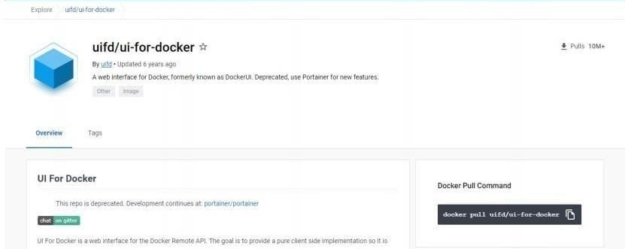

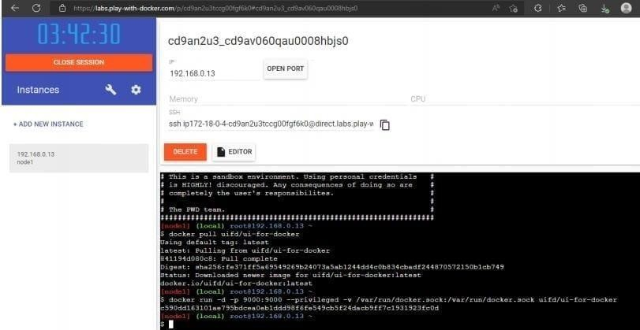

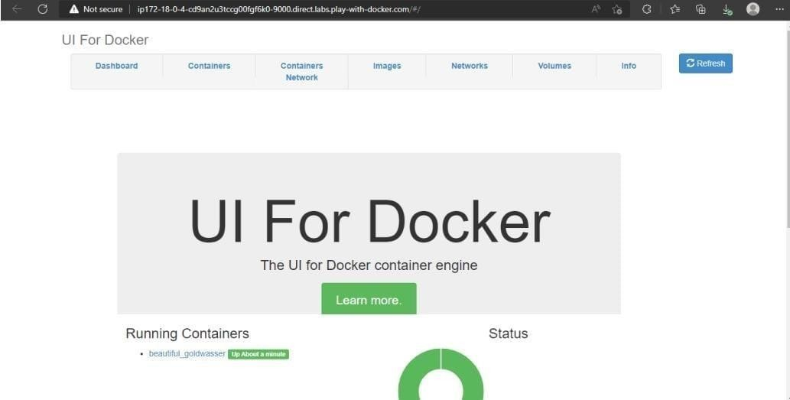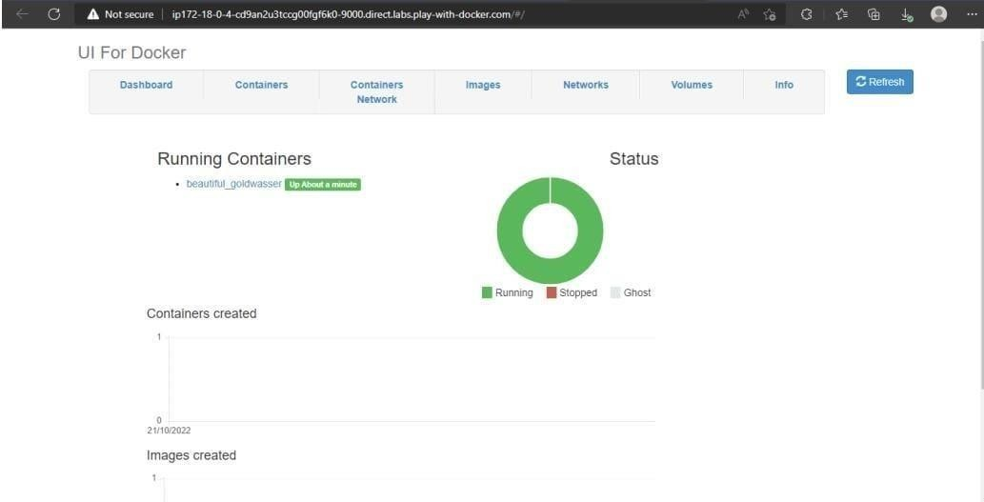

|  |
| --- |
| **Question-2:**  2. Create a docker file for the jobportal application and deploy it in Docker desktop application.  SOLUTION: |
|  |

# QUESTION-3:

1. Create a IBM container registry and deploy helloworld app or jobportalapp. Solution:

<html>

<body>

Hello, IBM Cloud World!

</body>

</html>--- applications:

- buildpack: https://github.com/cloudfoundry/staticfile-buildpack.git host: simple-website-${random}

name: simple-website-${random} memory: 64M

stack: cflinuxfs2

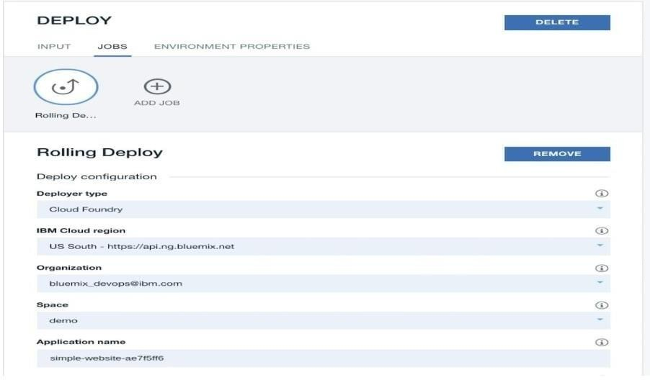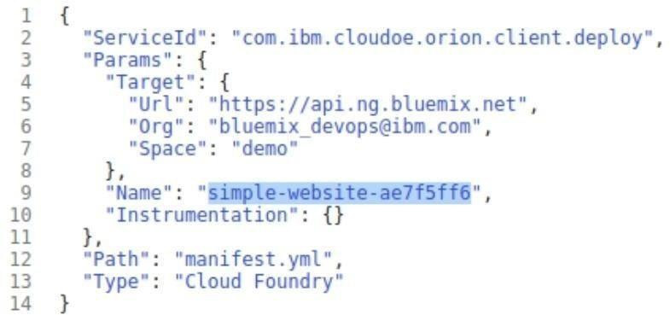

# QUESTION-4:

1. Create a Kubernetes cluster in IBM cloud and deploy helloworld image or jobportal image and also expose the same app to run in nodeport.

Solution:

ibmcloud target -g <resource_group_name>ibmcloud cr example-add

<your_example>ibmcloudresource service-instance-create example-postgresql databases-for- postgresql standard us- southibmcloud ks cluster-service-bind mycluster default example- postgresqlgit clone -b node git@github.com:IBM-Cloud/clouddatabases-helloworld-kubernetes- examples.gitspec:

replicas: 3name: cloudpostgres-nodejs-app

image: "registry.<region>.bluemix.net/<namespace>/icdpg" # Edit me

imagePullPolicy: Alwaysibmcloud cr regionYou are targeting region 'us-south', the registry is 'registry.ng.bluemix.net'.ibmcloud cr build -t registry.ng.bluemix.net/<namespace>/icdpg .ibmcloud cr images

env:

- name: BINDING valueFrom:

secretKeyRef:

name: <postgres-secret-name> # Edit me key: binding

apiVersion: v1 kind: Service metadata:

name: cloudpostgres-service labels:

run: clouddb-demo spec:

type: NodePort selector:

run: clouddb-demo ports:

- protocol: TCP port: 8080

nodePort: 30081

kubectl apply -f clouddb-deployment.yml deployment.apps/icdpostgres-app created service/cloudpostgres-service created

kubectl get pods -o wideibmcloud ks workers <your_cluster_name>

